1. Deck the Halls
- Deck the halls with boughs of holly - Fa la la la la, la la la la!
‘Tis the season to be jolly - Fa la la la la, la la la la!
Don we now our gay apparel - Fa la la la la, la la la la!
Troll the ancient Yuletide carol - Fa la la la la, la la la la!

- See the blazing Yule before us – Fa la la etc.
Strike the harp, and join the chorus – Fa la la etc.
Follow me in merry measure – Fa la la etc.
While I tell of Yuletide treasure – Fa la la etc.

- Fast away the old year passes – Fa la la etc.
Hail the new, ye lads and lasses – Fa la la etc.
Sing we joyous, all together – Fa la la etc.
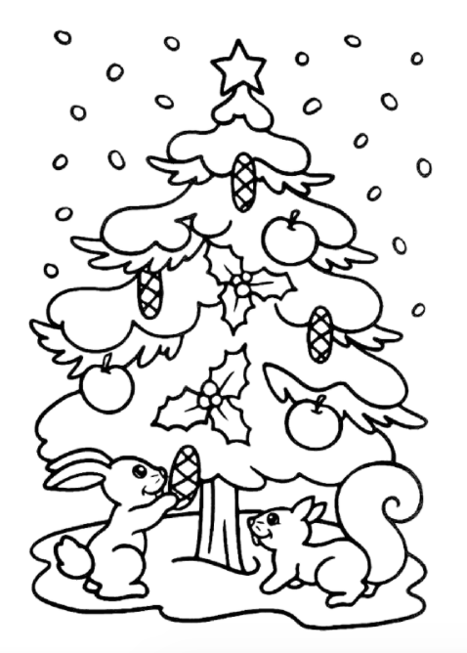
Heedless of the wind and weather – Fa la la etc.
2. O Come, All ye Faithful
- O Come, all ye faithful, joyful and triumphant
O come ye, O come ye to Bethlehem.
Come and behold him, born the king of angels
O come, let us adore him (x2)
O come let us adore him, Christ the Lord.

- God of God, light of light
Lo he abhors not the virgin’s womb
Very God, begotten not created
O come let us adore him (x2)
O come let us adore him, Christ the Lord

- Sing, choirs of angels
Sing in exultation
Sing, all ye citizens of heaven above.
Glory to God in the highest
O come let us adore him (x2)
O come let us adore him, Christ the Lord
3. Away in a Manger
- Away in a manger, no crib for a bed,
The little Lord Jesus lay down his sweet head.
The stars in the night sky looked down where he lay,
The little Lord Jesus, asleep in the hay.

- The cattle are lowing, the baby awakes,
But little Lord Jesus, no crying he makes.
I love thee, Lord Jesus, look down from the sky,
And stay by my cradle ‘til morning is nigh.
- Be near me, Lord Jesus, I ask thee to stay
Close by me forever, and love me, I pray.
Bless all the dear children in thy tender care,
And take us to heaven, to live with thee there.

4. Good King Wenceslas
- Good King Wenceslas looked out
On the feast of Stephen,
When the snow lay round about,
Deep, and crisp and even.
Brightly shone the moon that night,
Though the frost was cruel,
When a poor man came in sight,
Gath’ring winter fuel.

- Bring me flesh, and bring me wine;
Bring me pine logs hither.
Thou and I will see him dine,
When we bear them thither.
Page and monarch, forth they went;
Forth they went, together,
Through the rude wind’s wild lament
And the bitter weather.

- In his master’s steps he trod,
Where the snow lay dinted.
Heat was in the very sod
Which the saint had printed.
Therefore, Christian men, be sure,
Wealth or rank possessing,
Ye who now will bless the poor
Shall yourselves find blessing.

5. Rudolph, the Red-nosed Reindeer

Rudolph, the red-nosed reindeer
Had a very shiny nose
And, if you ever saw it,
You would even say it glows.

All of the other reindeer
Used to laugh, and call him names
They never let poor Rudolph
join in any reindeer games.

Then one foggy Christmas Eve,
Santa came to say:
“Rudolph, with your nose so bright,
Won’t you guide my sleigh tonight?”

Then, how the reindeer loved him,
As they shouted out with glee,
“Rudolph the Red-nosed reindeer,
You’ll go down in history!”

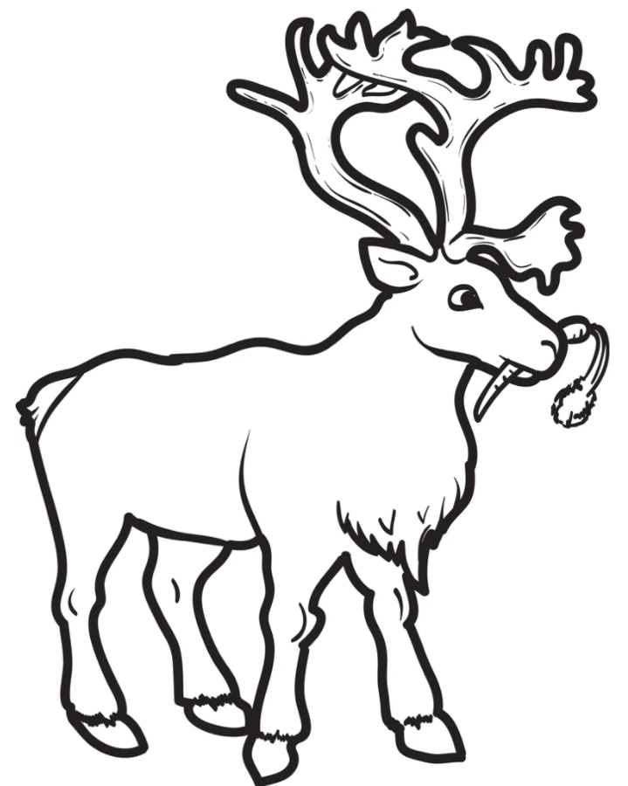
6. The First Nowell
The first nowell the angel did say
Was to certain poor shepherds in fields as they lay;
In fields as they lay, keeping their sheep
On a cold winter’s night that was so deep.
Nowell, nowell, nowell, nowell,
Born is the King of Israel.

They looked up and saw a star
Shining in the East, beyond them far
And to the Earth, it gave great light,
And so it continued both day and night.

Nowell , nowell etc.

Then let us all with one accord
Sing praises to our heavenly Lord
That hath made Heaven and Earth of naught,
And with his blood mankind hath bought.

Nowell, nowell etc.

7. The Twelve Days of Christmas

On the first day of Christmas,
my true love sent to me:
A partridge in a pear tree.

On the second day of Christmas,
my true love sent to me:
Two turtle doves,
And a partridge in a pear tree.

On the third day of Christmas,
my true love sent to me:
Three French hens,
Two turtle doves,
And a partridge in a pear tree.

On the fourth day of Christmas,
my true love sent to me:
Four calling birds,
Three French hens,
Two turtle doves,
And a partridge in a pear tree.

On the fifth day of Christmas,
my true love sent to me:
Five gold rings,
Four calling birds,
Three French hens,
Two turtle doves,
And a partridge in a pear tree.
On the sixth day of Christmas,
my true love sent to me:
Six geese a-laying,
Five gold rings,
Four calling birds,
Three French hens,
Two turtle doves,
And a partridge in a pear tree.

On the seventh day of Christmas,
my true love sent to me:
Seven swans a-swimming,
Six geese a-laying,
Five gold rings,
Four calling birds,
Three French hens,
Two turtle doves,
And a partridge in a pear tree.

On the eighth day of Christmas,
my true love sent to me:
Eight maids a-milking,
Seven swans a-swimming,
Six geese a-laying,
Five gold rings,
Four calling birds,
Three French hens,
Two turtle doves,
And a partridge in a pear tree.

On the ninth day of Christmas,
my true love sent to me:
Nine ladies dancing,
Eight maids a-milking,
Seven swans a-swimming,
Six geese a-laying,
Five gold rings,
Four calling birds,
Three French hens,
Two turtle doves,
And a partridge in a pear tree.

On the tenth day of Christmas,
my true love sent to me:
Ten lords a-leaping,
Nine ladies dancing,
Eight maids a-milking,
Seven swans a-swimming,
Six geese a-laying,
Five gold rings,
Four calling birds,
Three French hens,
Two turtle doves,
And a partridge in a pear tree.
On the eleventh day of Christmas,
my true love sent to me:
Eleven pipers piping,
Ten lords a-leaping,
Nine ladies dancing,
Eight maids a-milking,
Seven swans a-swimming,
Six geese a-laying,
Five gold rings,
Four calling birds,
Three French hens,
Two turtle doves,
And a partridge in a pear tree.
On the twelfth day of Christmas,
my true love sent to me:
Twelve drummers drumming,
Eleven pipers piping,
Ten lords a-leaping,
Nine ladies dancing,
Eight maids a-milking,
Seven swans a-swimming,
Six geese a-laying,
Five gold rings,
Four calling birds,
Three French hens,
Two turtle doves,
And a partridge in a pear tree.

8. Once in Royal David’s City
- Once in Royal David’s City
Stood a lowly cattle shed
Where a mother laid her baby
In a manger for his bed;
Mary was that mother mild,
Jesus Christ her little child.

- He came down to Earth from Heaven
Who is God, and Lord of all,
And his shelter was a stable,
And his cradle was a stall;
With the poor, and mean, and lowly
Lived on Earth our Saviour holy.

- And our eyes at last shall see him,
Through his own redeeming love;
For that child so dear and gentle
Is our Lord in Heav’n above.
And he leads his children on
To the place where he is gone.

9. Santa Claus is coming to town

You better watch out, you better not cry
Better not pout, I’m telling you why:
Santa Claus is comin’ to town!

He’s making a list, and checking it twice
Gonna find out who’s naughty and nice;
Santa Claus is comin’ to town!

He sees you when you’re sleepin’
He knows when you’re awake
He knows if you’ve been bad or good
So be good, for goodness sake!

Oh! You better watch out, you better not cry
Better not pout, I’m tellin’ you why:
Santa Claus is comin’ to town!

REPEAT

10. Ding, Dong, Merrily on High

- Ding, dong, merrily on high
In Heav’n the bells are ringing
Ding, dong, verily the sky
Is riv’n with angels singing.
Gloria, Hosanna in excelsis!
Gloria, Hosanna in excelsis!

- E’en so, here below, below
Let steeple bells be swungen,
And “I-o, i-o, i-o!”
By Priest and people sungen.
Gloria, Hosanna in excelsis!
Gloria, Hosanna in excelsis!

- Pray you, dutifully prime
Your matin chime, ye ringers;
May you beautifully rime
Your evetime song, ye singers.
Gloria, Hosanna in excelsis!
Gloria, Hosanna in excelsis!

11. God Rest Ye Merry, Gentlemen

- God rest ye merry, gentlemen
Let nothing you dismay,
Remember Christ, our Saviour,
Was born on Christmas Day
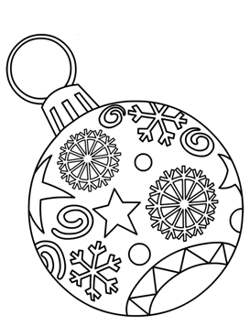
To save us all from Satan’s pow’r
When we were gone astray.
O tidings of comfort and joy,
Comfort and joy,
O tidings of comfort and joy!

- From God our heavenly Father
A blessed angel came,
And unto certain shepherds
Brought tidings of the same,
How that in Bethlehem was born
The Son of God by name.
O tidings of comfort and joy,
Comfort and joy,
O tidings of comfort and joy!

- Now to the Lord sing praises,
All you within this place,
And with true love and brotherhood
Each other now embrace;
This holy tide of Christmas
Doth bring redeeming grace.
O tidings of comfort and joy,
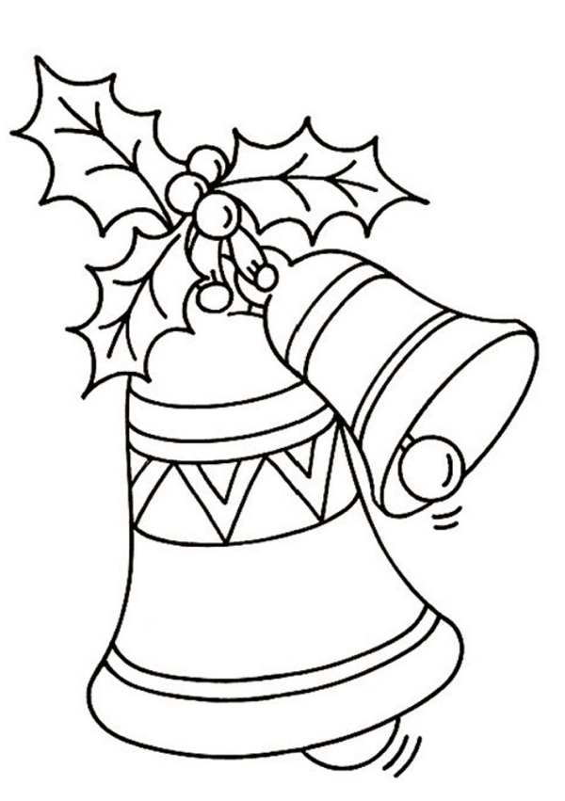
Comfort and joy,
O tidings of comfort and joy!
12. Jingle Bells

Oh, jingle bells, jingle bells
Jingle all the way
Oh, what fun it is to ride in a one-horse open sleigh
Jingle bells, jingle bells
Jingle all the way
Oh, what fun it is to ride in a one-horse open sleigh

A day or two ago
I thought I’d take a ride
And soon miss Fanny Bright
Was seated by my side.
The horse was lean and lank
Misfortune seemed his lot
We got into a drifted bank
And then we got upsot!
REPEAT VERSE 1

13. Hark! The Herald Angels Sing
- Hark! The herald angels sing:
“Glory to the new-born King;
Peace on Earth, and mercy mild,
God and sinners reconciled!”
Joyful, all ye nations rise,
Join the triumph of the skies;
With th’angelic host proclaim,
“Christ is born in Bethlehem!”
Hark! The herald angels sing:
“Glory to the new-born King!”

- Christ, by highest Heav’n adored;
Christ, the everlasting Lord;
Late in time, behold him come,
Offspring of a virgin’s womb.
Veiled in flesh the Godhead see,
Hail th’incarnate Deity,
Pleased with us in flesh to dwell,
Jesus our Emmanuel.
Hark! The herald angels sing:
“Glory to the new-born King!”

- Hail the heav’nly Prince of Peace!
Hail the Sun of Righteousness!
Light and life to all, He brings
Ris’n with healing in His wings.
Mild He lays His glory by,
Born that man no more may die;
Born to raise the sons of Earth,
Born to give them second birth.
Hark! The herald angels sing:“Glory to the new-born King!”
14. Have Yourself a Merry Little Christmas
Have yourself a merry little Christmas
Let your heart be light
From now on our troubles will be out of sight

Have yourself a merry little Christmas
Make the Yuletide gay
From now on
Our troubles will be miles away

Here we are, as in olden days
Happy, golden days of yore
Faithful friends who are dear to us
Gather near to us once more

Through the years we all will be together
If the fates allow
Hang a shining star upon the highest bough
And have yourself a merry little Christmas now.

15. White Christmas

I’m dreaming of a white Christmas
Just like the ones I used to know
Where the treetops glisten
And children listen
To hear sleigh bells in the snow

I’m dreaming of a white Christmas
With every Christmas card I write
May your days be merry and bright
And may all your Christmases be white

REPEAT

16. Silent Night

Silent night, holy night!
All is calm, all is bright.
Round yon Virgin, Mother and Child.
Holy infant so tender and mild,
Sleep in heavenly peace,
Sleep in heavenly peace

Silent night, holy night!
Shepherds quake at the sight.
Glories stream from heaven afar
Heavenly hosts sing Alleluia,
Christ the Saviour is born!
Christ the Saviour is born

Silent night, holy night!
Son of God love's pure light.
Radiant beams from Thy holy face
With dawn of redeeming grace,
Jesus Lord, at Thy birth
Jesus Lord, at Thy birth

